**Vision Statement**

Project members:

Ido Elmaleh, id – 206008153

Avichay nega , id - 309612307

Matan Tsabari , id – 302548565

Project goals

Constructing an automated machine that can feed small animals, cats for example, when no human is around.  
Alternatively, given a room full of cats, where a specific cat has to be fed by medical food, we'd want the ability to give the cat the option to be fed when he wants and not when the other cats want.

A distant goal for the project is to add an AI (machine learning) that could learn the eating time and behavior of the cat, thus providing a way to know when your cat hasn’t eaten in a long time,

Project scope

The project will include:

• Working with a cat or Any other small animal.

• Work with hardware components ESP32, RF R / W, and other kind of sensors.

• Create intergration between computer and components.

• Collecting information about feeding hours, eating times per day and more information to build a learning machine.

The project will not include:

* The project is based on existing technology - there is no attempt to create new technology

Essential and desirable features:

**Essential:**

* Automated feeding machine
* Fully operational hardware components

**Desirable:**

* Machine learning AI to analyze feeding hours
* Use AI to figure when cat is sick when he has not eaten properly

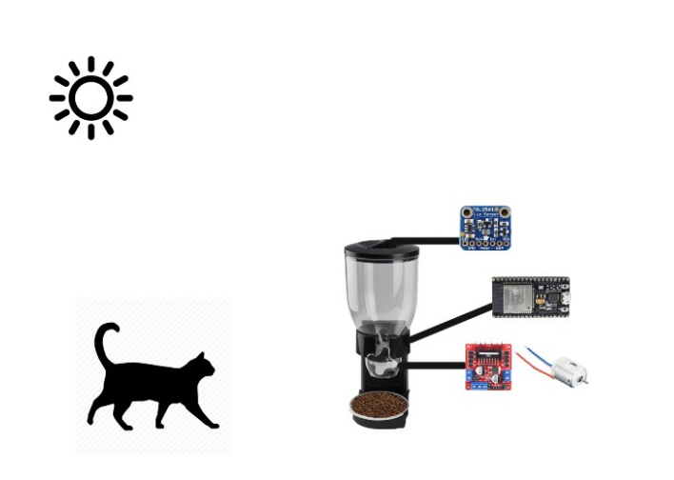

The product:

fully automated feeding machine, for a small animal, that could deliver your animal his food in times of need.

1. The system includes sensor/s to identify when your animal wishes to eat.
2. Stop over eating, or excess use of food for your animal.
3. Providing healthy eating habits and diet.
4. Give your animal the ability to be special with a unique identification process to use the machine.
5. Your animal will be fed privately, without the need for human or external help.
6. Analyzing and monitor your animal's eating behavior.

Elevator statement

An a automatic feeder is an essential technology each animal owner need to have in his possession in a fast world like ours.

The automatic feeder creates more free time for leisure to the animal owners by take care for the consumers their exhausting animal feeding

Chore.

The automatic feeder will be able to feed the consomers animals in any giving time in doses that are ideal for each individual animal, in addition to that the machine will implement a feeding plan based on the owner demand and by that will enforce good eating habbits for the animal,

And will contribute to the animal health.

In contrast to other feeding machines in the market currently the automatic feeder is cheap and have more applications such as building individual feeding plan for the animal, controlling the access of animal we want to use the machine and denying access for some we don’t and

Much more that makes the automatic feeder the best and ideal product

For animals owner in the market.